# Product Manager – Documentation

## Setup

1. Install all the node packages by running “node install” command.
2. Change the MongoDB server path and database name in file named “database-settings.js” in directory “config”.
3. Run the server. That’s it.

## Screenshots

**Home Page**

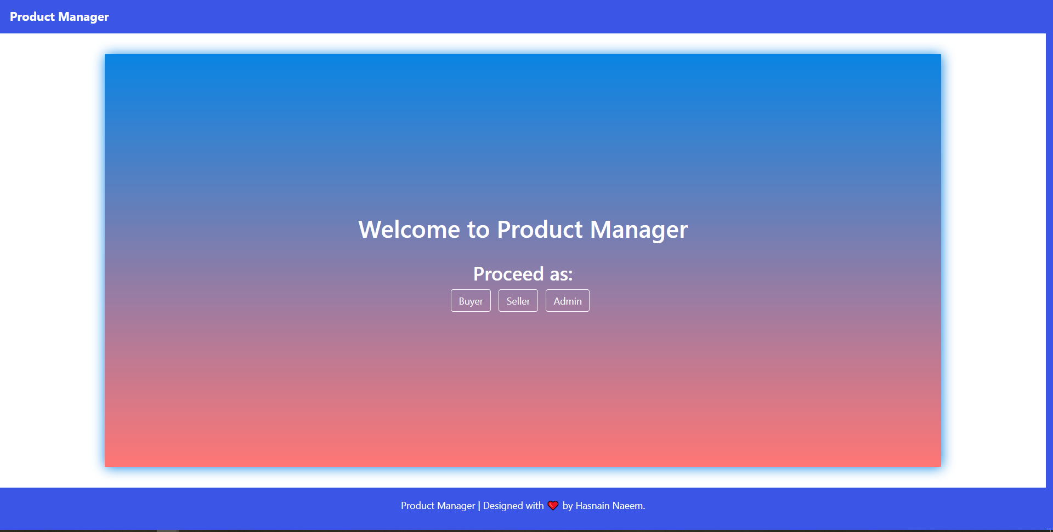

**Login Panel**

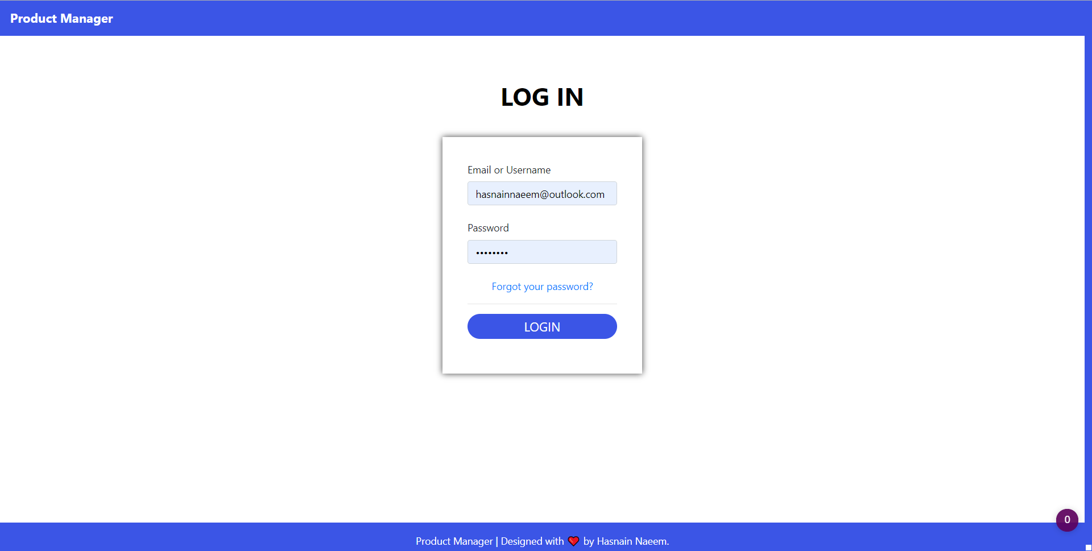

**Admin Panel**

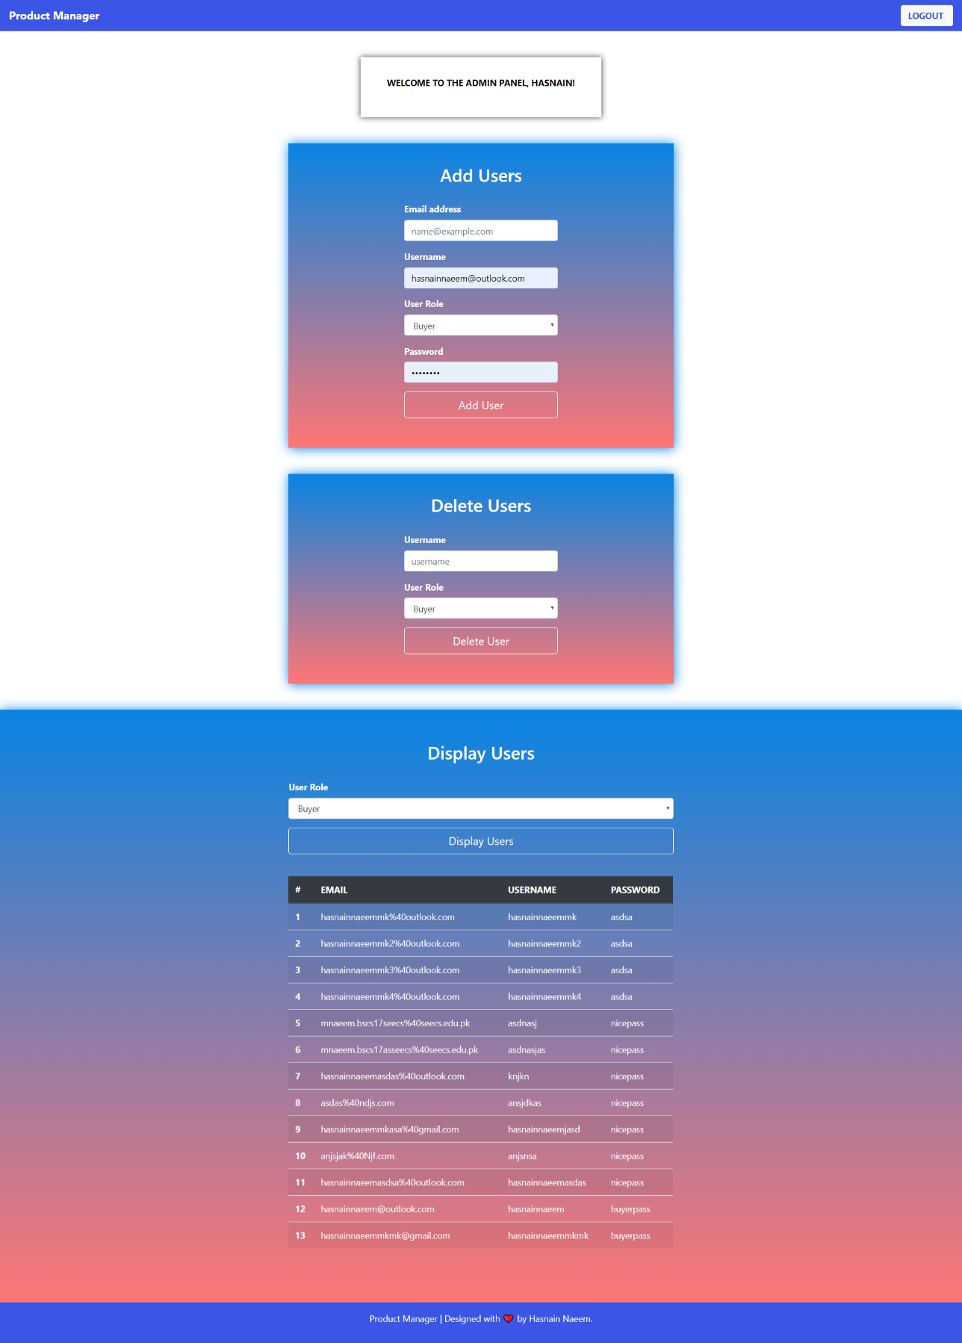

**Seller Panel**

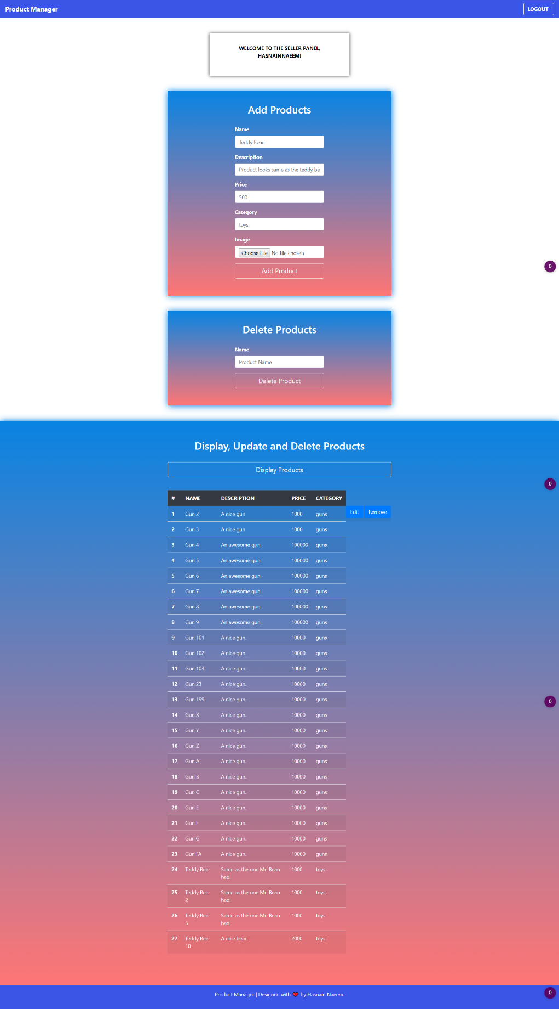

**Buyer Panel**

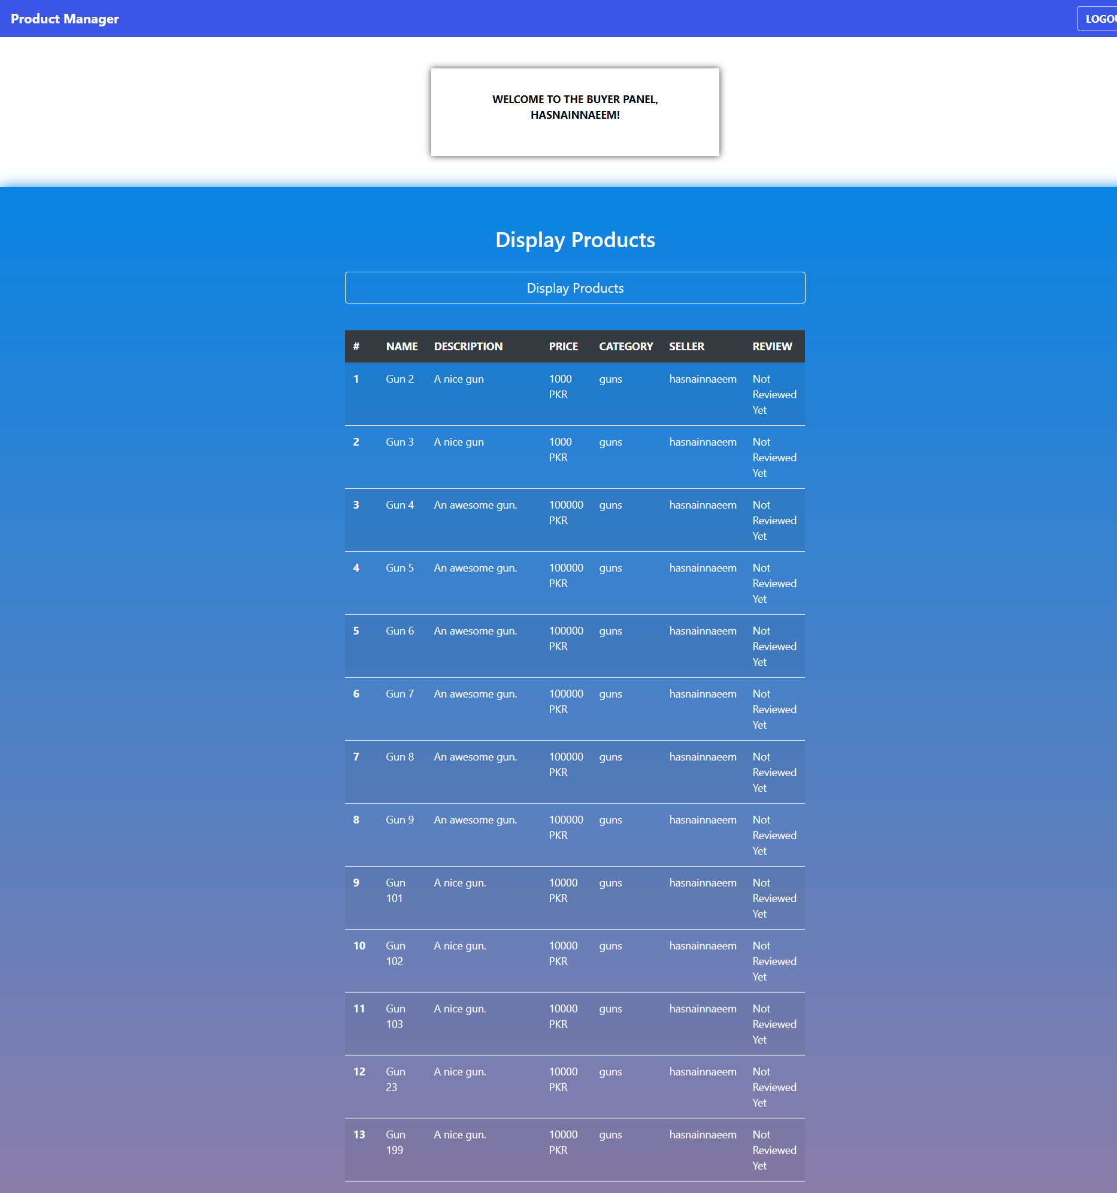

**When User Tries To Access Admin, Buyer or Seller Panels without Logging in:**

